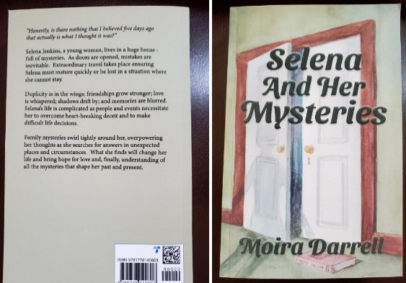
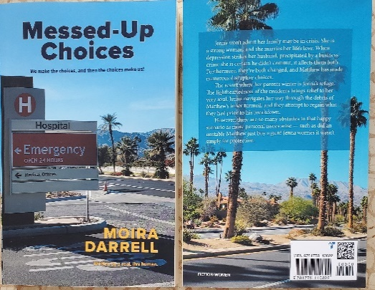

AUTOBIOGRAPHY

MOIRA DARRELL (WILEY)
Author of
MESSED-UP CHOICES
and
SELENA AND HER MYSTERIES
MOIRA DARRELL WILEY is my full name. However, I use my first and middle names to write because, unbelievably, there was already an author named Moira Wiley!
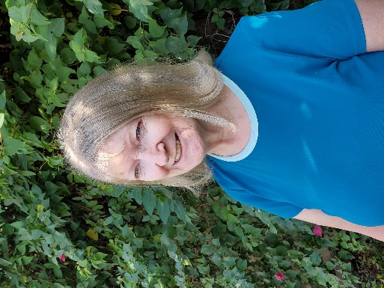
I was born and lived in a small town in Saskatchewan, then moved to Regina; however, I now live closer to the mountains in Alberta with my husband and kitty. Some family members are close by; others so far away that it brings tears to my eyes. Such is life.

I have been a daughter, a granddaughter, a sister, a wife, a mother, a grandmother, a legal secretary (for 22 years), a school admin secretary (for 12 years), a poet, a hand-sculpting potter in many techniques, dabbled in drawing, painting, have my second level of Reiki (as does Ashley in my second book). I am the author of MESSED-UP CHOICES and SELENA AND HER MYSTERIES.

As a teenager, I loved writing in Composition class and have written several poems, some of which found themselves in my books.

I am especially interested in the emotions of my characters (people), the friendships, the relationships, all influenced by people, events, and emotions in my own life. Not that any of these events necessarily happened to me, but the emotions still apply. I tend to get totally engrossed in the character’s emotions as I write and re-read segments of my books. I laugh, feel sad, get a tear in my eye, have anger at a deceit and delight in the happy parts of each book. These emotions and my characters do grab me and pull me along with them. And this is what I want to do with my readers. I want my readers to be pulled along by my story and the characters in my books.

I write about family drama, friendships, and relationships – throwing in as much humour as the story allows. I actually dislike the word ‘characters’ because the people in my books become like friends to me. Didn’t we all have imaginary friends when we were younger? Well, apparently, I still do.

I love nature and nurture, have had many pets – two closely resembling the animals in MESSED-UP CHOICES, and have loved them all. As she appears in “SELENA AND HER MYSTERIES”, I currently do have a kitty named Caylie Ceilidh Pretty Lady – really. My English Springer Spaniel, Snickers, now passed away, knew the hand commands described in SELENA AND HER MYSTERIES and now is part of my book, MESSED-UP CHOICES. Ringo, another English Springer Spaniel mentioned in MESSED-UP CHOICES, was my dog. He was a handful and a very overwhelming addition to my young family!!

I have volunteered for various groups throughout my life, such as community associations, city zone board, a women’s shelter, a housing project, pottery groups and a city arts' committee. I believe in giving to charity by time or donation if you are able.

I try to live my life to the best of my ability. And “instead of worrying about what was or what might be, rejoice in what IS.”

